**CS 262 – Database Management Systems Lab**

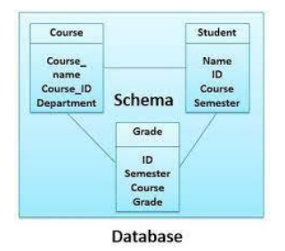

**WEEK 2 PROBLEMS**

**1. Create course and student tables by adding following constraints on the attributes:**

**a. Primary keys on course_id and student_id attributes.**

**b. Foreign key constraint on course_id attribute of student table.**

**c. Unique on course name.**

**d. Not null on student_name.**

**e. Check constraint on grade attribute of grade table. Grade should be between 5 to 10.**

**f. Set default value for department attribute of course table.**

**2. Write insert statements that violate the constraints specified in problem 1.**

**3. Write update statements that violate the constraints specified in problem 1.**

**4. Write delete statements that violate the constraints specified in problem 1.**

**5. Drop the constraints specified in problem 1 using alter table statements.**

**6. Add the constraints specified in problem 1 using alter table statements**